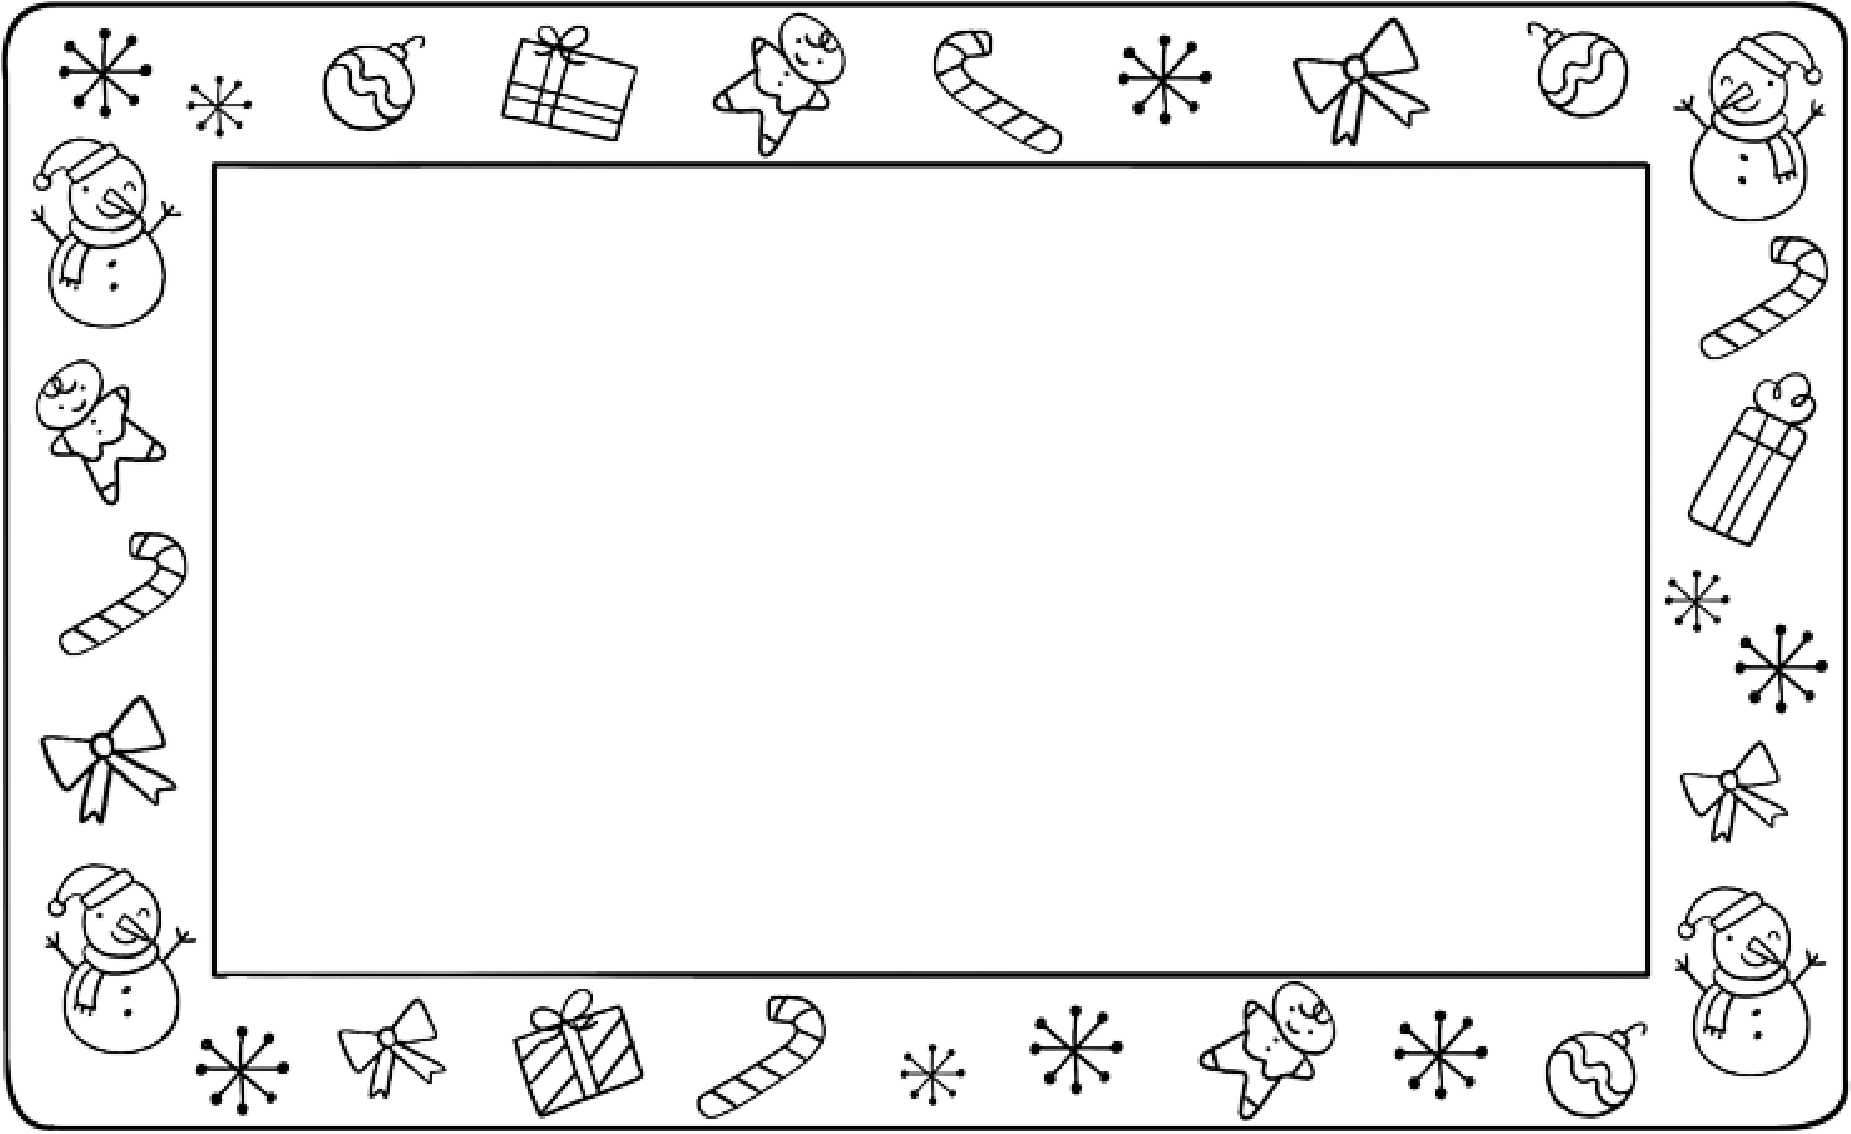
TEACHER: SCHOLASTIC INC. GRANTS YOU PERMISSION TO REPRODUCE THIS PAGE. © 2017 BY SCHOLASTIC INC. ILLUSTRATIONS: JULISSA MORA
Dear Friend,
I drew you a
__Picture____________________________________________
.
Happy holidays!
From
____________________________________________________
Writing and Drawing
My name

(First and Last Name)__________________________________
Send a Holiday Letter!
Make a holiday drawing for a friend. Then fill in the blanks.
Teachers:
Use this sheet with the activity on page 8 of your Teacher’s Guide.

